SODV 2101 Project Proposal

Group 2:

Paul K Kho

Yadwinder Singh Sidhu

David Hebert

Dima Marachi, Instructor

Due: October 5, 2021

**Project Description:**

A reminder app that allows users to set a time and/or date for them to be given a reminder in the form of a windows notification or sound notification. The app should allow users to create multiple reminders that have the option to be a single time reminder or repeating reminder.

**Key Features**

* Users should have the ability to create reminders
* Users should have the ability to delete reminders
* Users should have the ability to modify reminders, to change the time or date of a specific reminder
* Users should have the ability to see all their reminders, and see upcoming reminders
* Audio and visual alerts.
* User option storing data locally.

**Drawings of how the user interface might look like (with notes indicating how to use it.)**

**UML Diagram**

Initial UML Diagram (Subject to change)

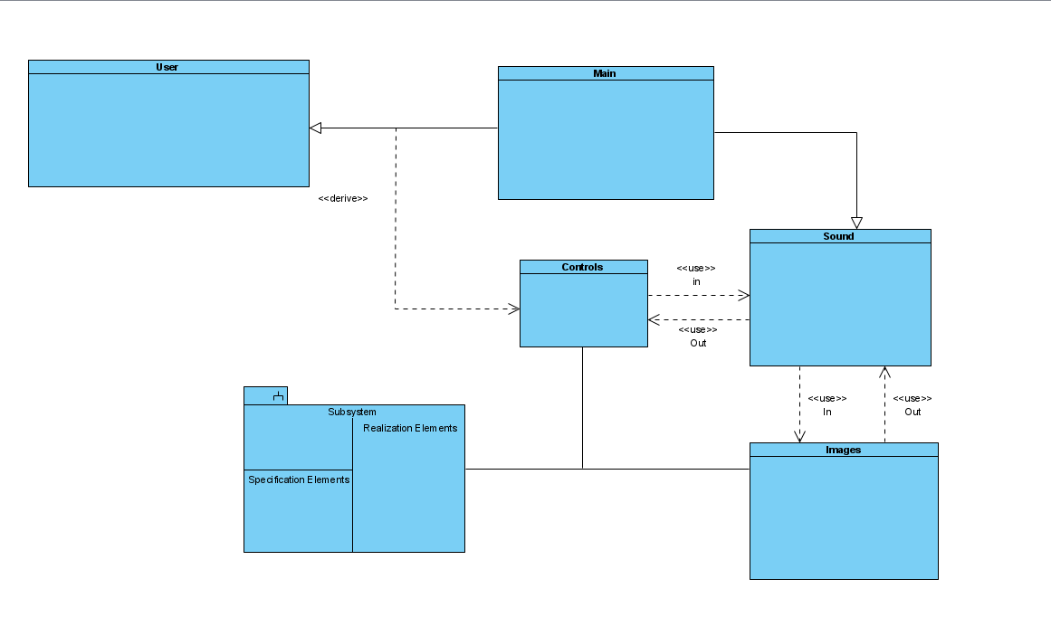

**Schedule**

We will divide the work into the key features and give different key features to each member, while communicating what each feature needs to be capable of to be able to work with other key features.

We will build our program according to the following schedule. Subject to change. We have scheduled this project to be ready before December 16, 2021. We will create and test the UI by end of October. We will complete coding by end of November. We will test, correct, trouble shoot and update our project, when necessary, before December 16th.